**IoT Project Proposal - 03/03/2017 – Loti Ibrahimi**

**Title:** Fino **– *Arduino Bird Feeder*.**

**Overview: Simple mechanical device which enables bird food to flow out to an open space, which may be set automatically.**

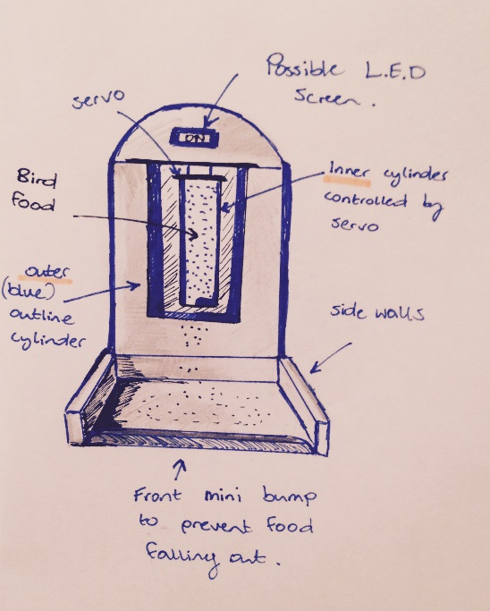

**Description: The physical stand is firstly made along with the food vault/passage which will be controlled using a servo as shown in the diagrams above/below. This servo is to be connected to an Arduino, where the code is then tested to check its functionality.**

**The servo cap is then connected to the end of a cylinder container as displayed in the diagrams, which will rotate at set intervals or times, releasing some food, only to be closed again until the next phase (due to closed half covering the food escape gap, after rotation).**

**A sensor could be implemented within the food vault which may be hooked up to a LCD screen and display empty - full depending on how much food is in store. This could also involve the use of the Raspberry Pi which could enable data on the apparatus to be collected wirelessly.** 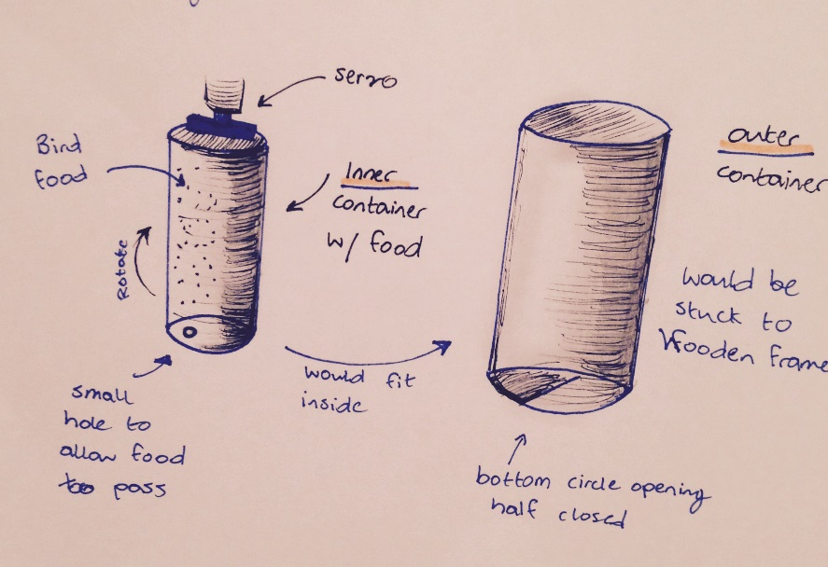

**Candidate Technologies/Domain:**

**Arduino / (possibly: Single Board Computer such as Raspberry Pi: for wireless data transfer).**

**Programming Language: Java/Javascript/Java/Python.**

**Servo.**

**2x Cylinder containers (one to fit almost perfectly in the other).**

**LCD Screen (possibly may be used).**

**Basic Wood Carvings (as indicated in diagram above).**

**Other Practical Skills:**

**Programming Fundamentals, minor woodworking, computer architecture, operating systems, digital electronics.**